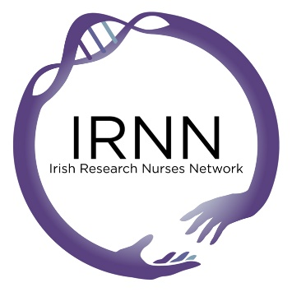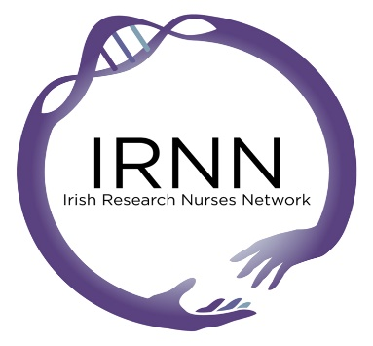
Research Nurse/Midwife Support & Development Grant 2017

Application Form

Surname
First Name(s)
Work Address
Email Address
Member of IRNN since (please state year)
Please state your contribution to, or participation in, IRNN activities (for example presenting, either oral or poster, abstract at an IRNN conference)

What event/workshop/conference do you wish to attend (please include dates and venue in your answer)?
What is your role in this event (i.e. are you on the committee, student, presenting an abstract or poster)?
Please provide details of the amount and type of funding requested (conference fees, accommodation and transport costs as applicable).
Have you secured any other funding to attend this event/workshop/conference?

If Yes, please state the amount and the name of the awarding body
How will this grant benefit you?
How will this grant benefit your colleagues and other research nurses/midwives?
How do you plan to provide feedback on your experience to the wider nursing/midwifery research community?

Signature (can be electronic)____________________________________________

Date ______________________________________________

Please return this form to hello@irnn.ie and use the subject heading ‘Research Nurse/Midwife Support & Development Grant 2017’.

